# PROJECT PLANNING PHASE MILESTONE & ACTIVITY LIST

|  |  |
| --- | --- |
| Date | 03 November 2022 |
| Team ID | |  | | --- | | **PNT2022TMID50383** | |
| Project Name | Fertilizers Recommendation System For Disease Prediction |

Milestone:

* The performance of Artificial Intelligence (AI) models is being improved and increased in modern technology.
* Based Crop Yield Disease Prediction System would assist farmers in protecting their crops from a variety of diseases by identifying them during the process of taking an image at the plant and providing the afflicted disease's name to a machine learning algorithm.
* The best answer for the farmer will be provided in this project milestone, and he or she may find it on their own by using a web application with a completely user-friendly and straightforward user interface.
* Additionally, we intend to add a useful Module that is a fertilizer prescription for a certain disease to the process. It can propose both artificial and natural fertilizer in a similar way.

# Activity List

1. Planning is a crucial role in project management because it allows team members to schedule their time on the project.
2. This activity demonstrates how the team members assigned and completed various tasks!
3. In Project we can Split into the Four Step of Phrases are
   * Phrase 1: Information Collection and Requirement Analysis
   * Phrase 2: Project Planning and Developing Modules
   * Phrase 3: Implementing the High Accuracy Deep Learning Algorithm to Perform.
   * Phrase 4: Deploying the Model on Cloud and Testing the Model and UI Performance.

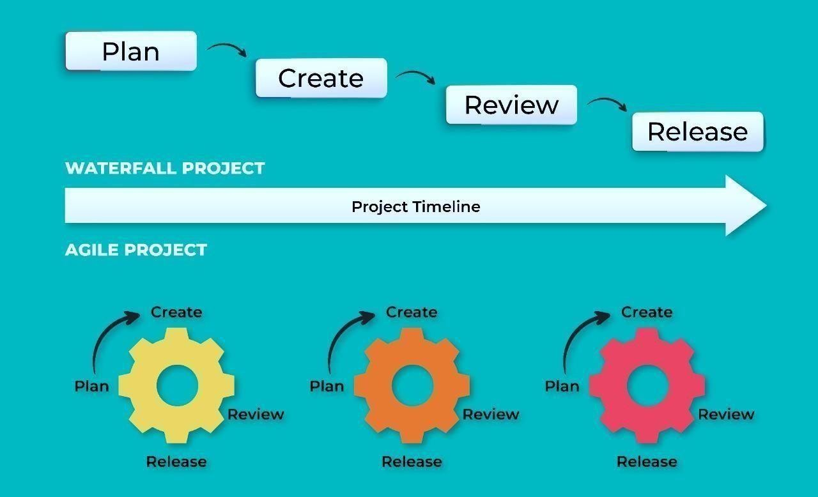

# Agile Methodology For Activity Planning